**데이터베이스 연동테스트 20071578 동해종**

1. **리스트 화면**

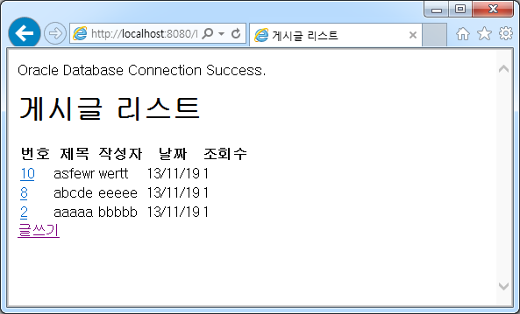

1. **글쓰기 화면**

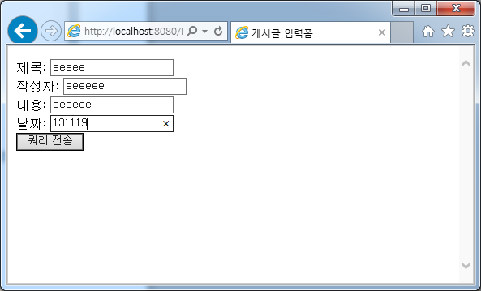

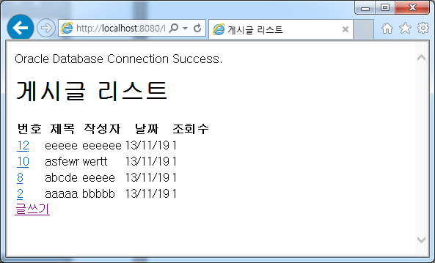

1. **상세보기 화면**

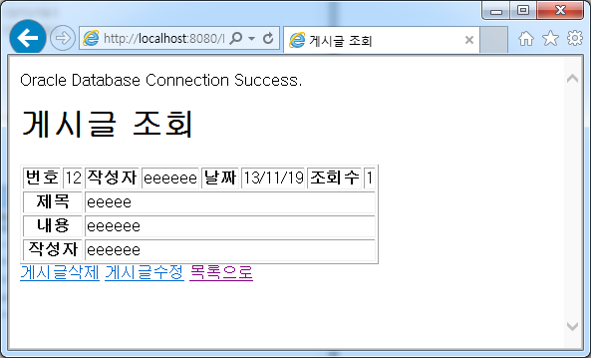

1. **수정 화면**

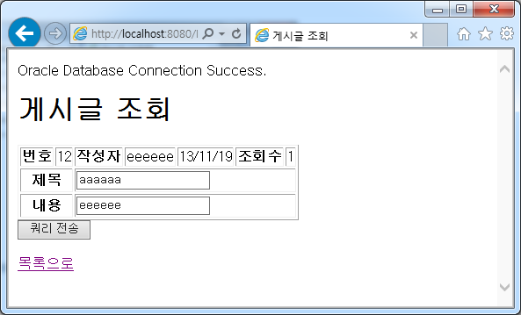

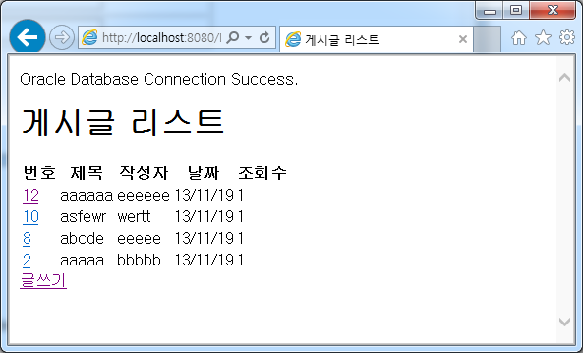

1. **삭제 화면**

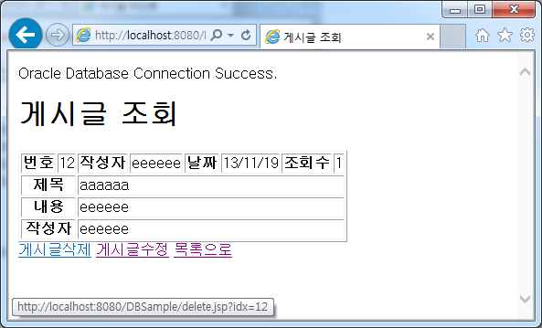

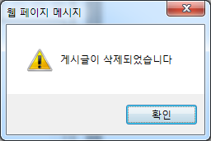

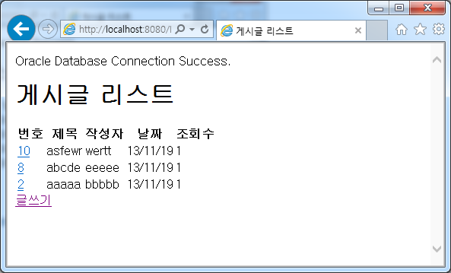

**삽입된 데이터 확인**

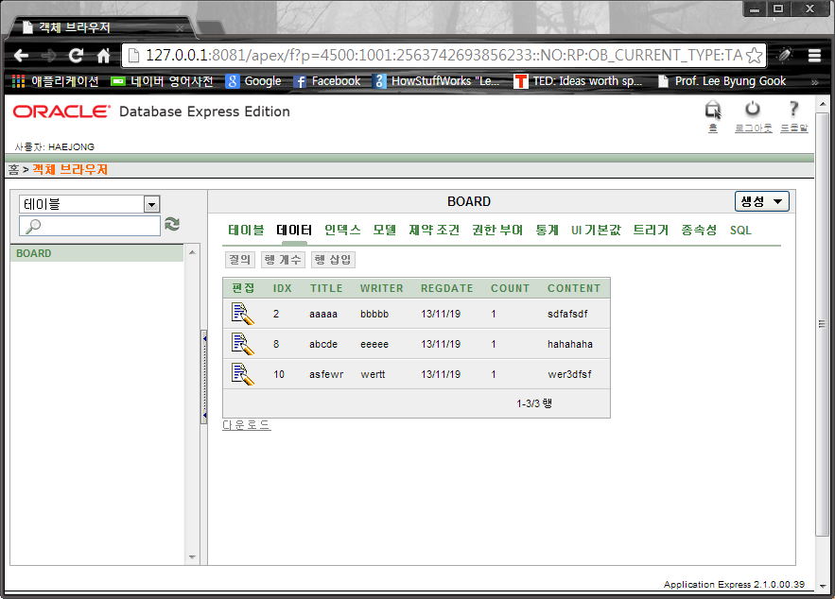

**설치환경 :**

Windows 32bit운영체제,

Oracle Database 10g Express Edition,

Apache-tomcat-7.0.47,

Jdk7u45-windows-i586,

Eclipse-jee-kepler-sr1-win32

**소스코드 :**

///////////////////////index.jsp /////////////////////////

<%@page import=*"java.util.regex.Pattern"* %>

<%@ page language=*"java"* contentType=*"text/html; charset=EUC-KR"*

pageEncoding=*"EUC-KR"*%>

<%@ page import=*"java.sql.*"* %>

<!DOCTYPE html PUBLIC "-//W3C//DTD HTML 4.01 Transitional//EN" "http://www.w3.org/TR/html4/loose.dtd">

<html>

<head>

<meta http-equiv=*"Content-Type"* content=*"text/html; charset=EUC-KR"*>

<title>게시글 리스트</title>

</head>

<body>

<%

request.setCharacterEncoding("euc-kr");

**int** idx = 1;

String title = request.getParameter("title");

String writer = request.getParameter("writer");

String regdate = request.getParameter("regdate");

**int** count = 10000;

String content = request.getParameter("content");

%>

<%

**try** {

String driverName = "oracle.jdbc.driver.OracleDriver";

String url = "jdbc:oracle:thin:@localhost:1521:XE";

ResultSet rs = **null**;

Class.forName(driverName);

Connection con = DriverManager.getConnection(url,"haejong","0000");

out.println("Oracle Database Connection Success.");

Statement stmt = con.createStatement();

String sql = "select * from board order by idx desc";

rs = stmt.executeQuery(sql);

%>

<h1>게시글 리스트</h1>

<table>

<tr>

<th>번호</th>

<th>제목</th>

<th>작성자</th>

<th>날짜</th>

<th>조회수</th>

</tr>

<%

**while**(rs.next()){

out.print("<tr>");

out.print("<td> <a href='content.jsp?idx="+ rs.getString("idx") +"'>" +

rs.getString("idx") + " </a></td>");

out.print("<td>" + rs.getString(2) + "</td>");

out.print("<td>" + rs.getString(3) + "</td>");

out.print("<td>" + rs.getString(4) + "</td>");

out.print("<td>" + rs.getString(5) + "</td>");

}

%>

</table>

<a href=*"write.jsp"*>글쓰기</a>

<%

con.close();

} **catch**(Exception e){

out.println("Oracle Database Connection Something Problem. <hr>");

out.println(e.getMessage());

e.printStackTrace();

}

%>

</body>

</html>

///////////// write.jsp//////////////////////

<%@ page language=*"java"* contentType=*"text/html; charset=EUC-KR"*

pageEncoding=*"EUC-KR"*%>

<!DOCTYPE html PUBLIC "-//W3C//DTD HTML 4.01 Transitional//EN" "http://www.w3.org/TR/html4/loose.dtd">

<html>

<head>

<meta http-equiv=*"Content-Type"* content=*"text/html; charset=EUC-KR"*>

<title>게시글 입력폼</title>

</head>

<body>

<form action=*"insert.jsp"* method=*"post"*>

제목: <input type=*"text"* name=*"title"*/> <br/>

작성자: <input type=*"text"* name=*"writer"*/> <br/>

내용: <input type=*"text"* name=*"content"*/> <br/>

날짜: <input type=*"text"* name=*"regdate"*/> <br/>

<input type=*"submit"* />

</form>

</body>

</html>

///////////// insert.jsp//////////////////////////

<%@page import=*"java.util.regex.Pattern"* %>

<%@ page language=*"java"* contentType=*"text/html; charset=EUC-KR"*

pageEncoding=*"EUC-KR"*%>

<%@page import=*"java.sql.*"* %>

<!DOCTYPE html PUBLIC "-//W3C//DTD HTML 4.01 Transitional//EN" "http://www.w3.org/TR/html4/loose.dtd">

<html>

<head>

<meta http-equiv=*"Content-Type"* content=*"text/html; charset=EUC-KR"*>

<title>Insert title here</title>

</head>

<%

String title = request.getParameter("title");

String writer = request.getParameter("writer");

String regdate = request.getParameter("regdate");

String content = request.getParameter("content");

**try**{

String driverName = "oracle.jdbc.driver.OracleDriver";

String url = "jdbc:oracle:thin:@localhost:1521:XE";

Class.forName(driverName);

Connection con = DriverManager.getConnection(url, "haejong", "0000");

out.println("Oracle 데이터베이스 db에 성공적으로 접속했습니다");

Statement stmt = con.createStatement();

String sql = "INSERT INTO BOARD "+

"(IDX, TITLE, WRITER, REGDATE, COUNT, CONTENT) "+

"VALUES (board_seq.nextval, '"+title+"', '"+writer+"', sysdate, '1', '"+content+"')";

stmt.executeUpdate(sql);

con.close();

} **catch** (Exception e) {

out.println("Oracle 데이터베이스 db 접속에 문제가 있습니다. <hr>");

out.println(e.getMessage());

e.printStackTrace();

} **finally**{

out.print("<script>location.href='index.jsp';</script>");

}

%>

<body>

</body>

</html>

//////////////content.jsp////////////////////

<%@page import=*"java.util.regex.Pattern"*%>

<%@ page language=*"java"* contentType=*"text/html; charset=EUC-KR"*

pageEncoding=*"EUC-KR"*%>

<%@ page import=*"java.sql.*"* %>

<!DOCTYPE html PUBLIC "-//W3C//DTD HTML 4.01 Transitional//EN" "http://www.w3.org/TR/html4/loose.dtd">

<html>

<head>

<meta http-equiv=*"Content-Type"* content=*"text/html; charset=EUC-KR"*>

<title>게시글 조회</title>

</head>

<%

String idx = request.getParameter("idx");

**try** {

String driverName = "oracle.jdbc.driver.OracleDriver";

String url = "jdbc:oracle:thin:@localhost:1521:XE";

ResultSet rs = **null**;

Class.forName(driverName);

Connection con = DriverManager.getConnection(url,"haejong","0000");

out.println("Oracle Database Connection Success.");

Statement stmt = con.createStatement();

String sql = "select * from board where idx = " + idx ;

rs = stmt.executeQuery(sql);

**while**(rs.next()){

%>

<body>

<h1>게시글 조회</h1>

<table border=*"1"*> <!-- border은 테두리를 표시하는 속성입니다. -->

<tr>

<th>번호</th>

<td><%=rs.getString("idx")%></td>

<th>작성자</th>

<td><%=rs.getString("writer")%></td>

<th>날짜</th>

<td><%=rs.getString("regdate")%></td>

<th>조회수</th>

<td><%=rs.getString("count")%></td>

</tr>

<tr>

<th colspan=*"2"*>제목</th> <!-- colspan은 행병합 속성입니다. -->

<td colspan=*"6"*><%= rs.getString("title")%></td>

</tr>

<tr>

<th colspan=*"2"*>내용</th>

<td colspan=*"6"*><%= rs.getString("content")%></td>

</tr>

<tr>

<th colspan=*"2"*>작성자</th>

<td colspan=*"6"*><%= rs.getString("writer")%></td>

</tr>

</table>

<a href=*"delete.jsp?idx=*<%=rs.getString("idx")%>*"*>게시글삭제</a>

<a href=*"update.jsp?idx=*<%=rs.getString("idx")%>*"*>게시글수정</a>

<a href=*"index.jsp"*>목록으로</a>

<%

}

con.close();

}**catch** (Exception e) {

out.println("Oracle Database Connection Something Problem. <hr>");

out.println(e.getMessage());

e.printStackTrace();

}

%>

</body>

</html>

//////////////delete.jsp////////////////////

<%@ page language=*"java"* contentType=*"text/html; charset=EUC-KR"*

pageEncoding=*"EUC-KR"*%>

<%@ page import=*"java.sql.*"* %>

<!DOCTYPE html PUBLIC "-//W3C//DTD HTML 4.01 Transitional//EN" "http://www.w3.org/TR/html4/loose.dtd">

<html>

<head>

<meta http-equiv=*"Content-Type"* content=*"text/html; charset=EUC-KR"*>

<title>게시글 삭제</title>

</head>

<%

String idx = request.getParameter("idx");

**try** {

String driverName = "oracle.jdbc.driver.OracleDriver";

String url = "jdbc:oracle:thin:@localhost:1521:XE";

Class.forName(driverName);

Connection con = DriverManager.getConnection(url,"haejong","0000");

out.println("Oracle Database Connection Success.");

Statement stmt = con.createStatement();

String sql = "delete from board where idx = " + idx ; // 삭제 쿼리입니다.

stmt.executeQuery(sql);

con.close();

}**catch** (Exception e) {

out.println("Oracle Database Connection Something Problem. <hr>");

out.println(e.getMessage());

e.printStackTrace();

}

%>

<script>

alert("게시글이 삭제되었습니다"); // 게시글이 삭제되었다는 경고창을 띄워주고

location.href="redirect.jsp"; // 리스트페이지로 이동합니다.

</script>

<body>

</body>

</html>

//////////////////redirect.jsp//////////////////////

<%@ page language=*"java"* contentType=*"text/html; charset=EUC-KR"*

pageEncoding=*"EUC-KR"*%>

<!DOCTYPE html PUBLIC "-//W3C//DTD HTML 4.01 Transitional//EN" "http://www.w3.org/TR/html4/loose.dtd">

<html>

<head>

<meta http-equiv=*"Content-Type"* content=*"text/html; charset=EUC-KR"*>

<title>Insert title here</title>

</head>

<script>location.href="index.jsp";</script>

<body>

</body>

</html>

/////////////////update.jsp////////////////////////

<%@page import=*"java.util.regex.Pattern"* %>

<%@ page language=*"java"* contentType=*"text/html; charset=EUC-KR"*

pageEncoding=*"EUC-KR"*%>

<%@ page import=*"java.sql.*"* %>

<!DOCTYPE html PUBLIC "-//W3C//DTD HTML 4.01 Transitional//EN" "http://www.w3.org/TR/html4/loose.dtd">

<html>

<head>

<meta http-equiv=*"Content-Type"* content=*"text/html; charset=EUC-KR"*>

<title>게시글 조회</title>

</head>

<%

String idx = request.getParameter("idx");

**try** {

String driverName = "oracle.jdbc.driver.OracleDriver";

String url = "jdbc:oracle:thin:@localhost:1521:XE";

ResultSet rs = **null**;

Class.forName(driverName);

Connection con = DriverManager.getConnection(url,"haejong","0000");

out.println("Oracle Database Connection Success.");

Statement stmt = con.createStatement();

String sql = "select * from board where idx = " + idx ;

rs = stmt.executeQuery(sql);

**while**(rs.next()){

%>

<body>

<h1>게시글 조회</h1>

<table border=*"1"*> <!-- border은 테두리를 표시하는 속성입니다. -->

<tr>

<th>번호</th>

<td><%=rs.getString("idx")%></td>

<th>작성자</th>

<td><%=rs.getString("writer")%></td>

<td><%=rs.getString("regdate")%></td>

<th>조회수</th>

<td><%=rs.getString("count")%></td>

</tr>

<form action=*"updateOK.jsp"* method=*"post"*>

<tr>

<th colspan=*"2"*>제목</th>

<td colspan=*"6"*><input type=*"text"* name=*"uTitle"* value=*"*<%= rs.getString("title")%>*"*/></td>

</tr>

<tr>

<th colspan=*"2"*>내용</th>

<td colspan=*"6"*><input type=*"text"* name=*"uContent"* value=*"*<%= rs.getString("content")%>*"*/></td>

</tr>

</table>

<input type=*hidden* name=*"idx"* value=*"*<%= rs.getString("idx")%>*"*>

<input type=*"submit"* />

</form>

<a href=*"index.jsp"*>목록으로</a>

<%

}

con.close();

}**catch** (Exception e) {

out.println("Oracle Database Connection Something Problem. <hr>");

out.println(e.getMessage());

e.printStackTrace();

}

%>

</body>

</html>

////////////////////updateOK.jsp//////////////////

<%@page import=*"java.util.regex.Pattern"* %>

<%@ page language=*"java"* contentType=*"text/html; charset=EUC-KR"*

pageEncoding=*"EUC-KR"*%>

<%@page import=*"java.sql.*"* %>

<!DOCTYPE html PUBLIC "-//W3C//DTD HTML 4.01 Transitional//EN" "http://www.w3.org/TR/html4/loose.dtd">

<html>

<head>

<meta http-equiv=*"Content-Type"* content=*"text/html; charset=EUC-KR"*>

<title>Insert title here</title>

</head>

<%

String idx = request.getParameter("idx");

System.out.println(idx);

**int** iIdx = Integer.parseInt(idx);

String title = request.getParameter("uTitle");

String content = request.getParameter("uContent");

**try** {

String driverName = "oracle.jdbc.driver.OracleDriver"; //데이터베이스에 접속하기위한 드라이버를 로드합니다.

String url = "jdbc:oracle:thin:@localhost:1521:XE"; //접속 URL정보와 포트번호(oracle포트), sid(oracle버전)

Class.forName(driverName);

Connection con = DriverManager.getConnection(url,"haejong","0000"); // getCo... : 계정정보 url, id, pw

out.println("Oracle 데이터베이스 db에 성공적으로 접속했습니다");

Statement stmt = con.createStatement(); // SQL 쿼리를 날리기위한 Statement 객체 생성

String sql = "update board set title='"+title+"' ,content='"+content+"' where idx='"+iIdx+"'"; // 수정 쿼리입니다.

stmt.executeUpdate(sql);

con.close();

} **catch** (Exception e) {

out.println("Oracle 데이터베이스 db 접속에 문제가 있습니다. <hr>");

out.println(e.getMessage());

e.printStackTrace();

} **finally**{

out.print("<script>location.href='index.jsp';</script>");

}%>

<body>

</body>

</html>